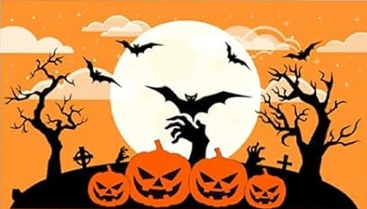

**«First_Name»**

**«City»**

**«Country_»**

**🚩"Join us, if you dare... The night awaits, and so do the shadows."**

You're invited to a night of eerie fun and spine-chilling thrills! Join us for a Halloween party full of haunted vibes, wicked costumes, and creepy cocktails. The darkness calls—will you answer? Come if you dare, but beware… once you enter, the fun might just be more than you can handle.